
CSE422: Artificial Intelligence
A
Summer 2025
Theory QUIZ-02
Duration: 40 Minutes

Name: | ID: | Section:

Question-01
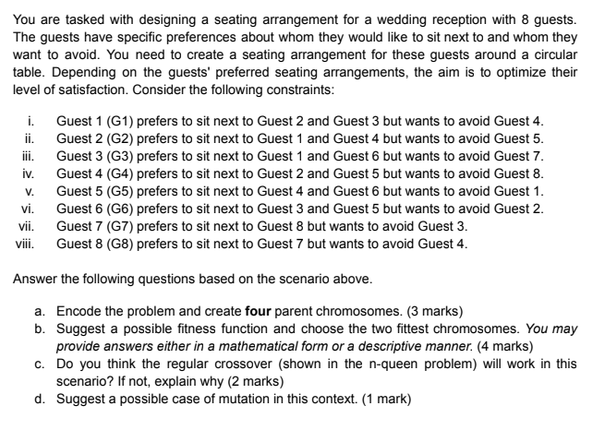

Question-02

1) Let’s say an Agent and Human are playing a game of chess and after 10 turns the Agent won the match. Determine how many times the agent ran Alpha-Beta pruning during the match. Explain in few sentences(2 marks)
2) Does ordering of the leaf nodes of a state space tree change the outcome of the MiniMax Algorithm?
Assume p,q,r,s to be some natural numbers which represent the fitness value of the leaf nodes, then show if ordering does affect the outcome of MiniMax algorithm or not. (5 marks)
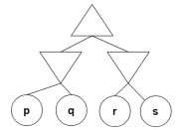
3) For what value of ‘x’ would the branch from node C to node G gets pruned?
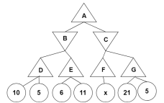


CSE422: Artificial Intelligence
B
Summer 2025
Theory QUIZ-02
Duration: 40 Minutes

Name: | ID: | Section:

Question-01
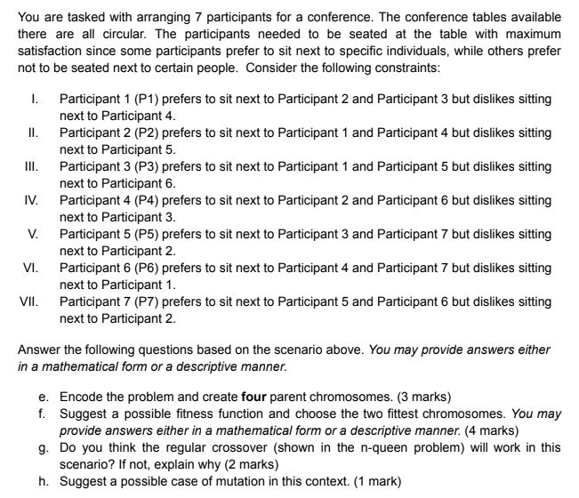

Question-02
1. Let’s say an Agent and Human is playing a game of chess and after 10 turns the Agent lost the match. Determine how many times the agent ran MiniMax Algorithm pruning during the match. Explain in few sentences(2 marks)
2. Does ordering of the leaf nodes of a state space tree change the outcome of Alpha Beta pruning Algorithm?
Assume p,q,r,s to be some natural numbers which represent the fitness value of the leaf nodes, then show if ordering does affect the outcome of Alpha Beta algorithm or not. (5 marks)

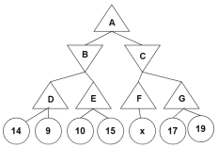
3. For what value of ‘x’ would the branch from node C to node G get pruned?

